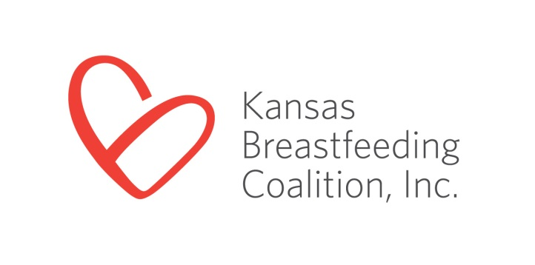

3005 Cherry Hill
Manhattan, KS 66503
785-477-4666
info@ksbreastfeeding.org
www.ksbreastfeeding.org

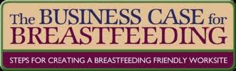

Human Resources [Insert Date] [Insert Company Name]

RE: Breastfeeding Employee Support Award

Dear Human Resource Division,

The Business Case for Breastfeeding is a program administered by the Kansas Breastfeeding Coalition, a non-profit organization, to assist employers in developing or enhancing support services for their breastfeeding employees. Many mothers abandon breastfeeding when they return to work because they lack the support and appropriate facilities at their place of employment.

It appears [Insert Company Name] has helped addressed this unfortunate situation. Your high level of support of your breastfeeding employees has been brought to our attention by members of your community. We would like to shine the spotlight on [Insert Company Name] for doing their part to make returning to work while breastfeeding easier. To view a list of other award-winning Kansas employers, visit http://www.kansasbusinesscase.com/for_employers/employer_awards . Employers receiving the “Breastfeeding Employee Support Award” receive a press release, listing on our website, and a certificate framed in a clock.

Please take a moment to complete the enclosed application and return it to me at your earliest convenience. We look forward to providing the recognition you deserve for supporting your breastfeeding employees. Please feel free to contact me should you have any questions.

Sincerely,

[Insert Your Signature Block]
OR
Brenda Bandy
Program Director
Business Case for Breastfeeding
www.kansasbusinesscase.com
3005 Cherry Hill, Manhattan, KS 66503
(785) 477-4666
bandy@kansasbusinesscase.com

